Yale School of Engineering & Appied Science Space Meeting
Becton Engineering Café & Lobby– LED Wall White Paper
August 13, 2012
Overview:
The Becton Engineering Café is intended to serve as community space for the School of Engineering & Applied Science. The café will be staffed with café employees for a set number of hours each day, serving food and coffee. The café is envisioned to remain accessible via key card access to the Yale community 24/7.

There will be range of potential users of the café room lights, the café sound system and the café LED wall. For all of these systems, user control will be required as well as supervisory control. The scope of this white paper is limited to the control features associated with the LED wall which covers 356 square feet piece of wall/ceiling and include over 23,000 LED lights, with each light individually programmable, and display custom images and video.
In addition to the café LED wall, the Becton installation will include 15 P/CK iColor tiles (1,860 LED lights) located in the lobby. These tiles would only be programmed by the Yale School of Engineering & Applied Science System Administrator. The lobby LED system is designed to have the flexibility of adding sensors in the lobby (at a later date) to allow the lights to respond to input from these sensors.
The purpose of this white paper is to share an understanding of the system and its operation with all involved (Yale School of Engineering, Yale Facilities, Charney Architects, Bentel & Bentel Architects, Philips/Color Kinetics, and HB Communications, Inc.) to achieve an optimal solution of operational and aesthetics criteria. Corrections to the explanations/assumptions presented in this white paper are invited and welcomed.

LED System Riser Diagram:

A system riser diagram (as submitted by Justin Rawlings (P/CK) in a July 26, 2012 email) is enclosed (at the end of this document) as a starting point for the system layout and interface discussion. Though not shown on this riser diagram, it is envisioned that the Pharos Lighting Playback Controller be located in the Equipment Space (as future plans call for using sensors in the lobby to respond to sensor inputs that originate in the lobby).

It is proposed (by Bentel & Bentel) that the Control Station on this riser diagram be in fact located in the Equipment Space, with access to the input ports on the Hippo Critter and Video System Engine Pro provided via a Creston controller & associated panel access boards (supplied and programmed by HB Communications) located in the café. The Pharos BPS and CAT5E Jack would remain in the café, along with the Creston controller and the required interface access junctions.

System Architecture – An Initial Explanation:

Before determining a user interface solution for the two LED display located in the lobby and café, an understanding of the overall system is needed.

The two sets of lights are intended to be controlled separately. Each LED is powered via a Philips/Color Kinetics sPDS-480ca 12V power/data supply (with 28 units used for the café LED wall, and 3 units used for the lobby LEDs, and 3 spares, all located in the Equipment Space).
The power supplies are controlled via the Philips/Color Kinetics Video System Manager Pro (VSM Pro) which is an integrated hardware and software video playback and visual effects display for Ethernet-based LED lighting installations. It is noted that the VSM Pro consists of the Video System Engine Pro (VSE Pro) controller device and the Video Management Tool (VMT) software to create video maps of the installation that directs source video pixels with their destination nodes in the lighting system. The VSE does not store video files but rather accepts content from a media source and then manipulates that content for optimal display on the LED system(s). The media source can be a digital media server, personal computers (either with digital or analog output cards), DVD players, camcorders, or digital media servers. It is envisioned that while the VSM can accept a variety of sources, this installation will only use a digital media server (the Hippo Critter) as the system input,.

The Hippo Critter serves as the media server for the system to allow for real-time video playback, manipulation and effects. The Hippo Critter can be thought of as a specialized computer (that runs on the Microsoft Operating System) and delivers content via two Digital Visual Interface (DVI) ports, with one port used as a system control screen and the other output port serving as the input signal for the lighting system. Two software programs must run to drive the Hippo Critter: ZooKeeper and Hippo-Engine. The Hippo-Engine software resides on the Hippo Critter and is the backbone of this media server’s operation and function for all of the graphics processing and video output. The ZooKeeper software serves as the system’s user interface for the Hippo Critter system. ZooKeeper can reside on the Hippo Critter machine or can be run on an external Windows machine (using an external dongle available from “tmb Products”). For this application, it is envisioned that the ZooKeeper and Hippo-Engine reside and are run on the Hippo-Critter. This assumption necessitates that the Hippo Critter computer interface controls be accessible in the café as well as the control monitor (which is driven via the Control DVI output on the Hippo Critter). While a remote computer can run ZooKeeper, it is desired to also have direct access to this control software in the café. The monitor/keyboard/mouse that would be accessed to run ZooKeeper in the space could be viewed as being portable, with the monitor/keyboard/mouse then removed from the space when a loaded LED display show is up and running.

Images/video-files for manipulation, playback and display are loaded on the Media-V3 folder on the C-drive of the Hippo Critter. These media files can include Quicktime, MPEG (MPEG2 preferred), AVI, and Windows Media video and JPEG, BMP, TIFF images (as well as other formats). USB connection to the Hippo Critter and connection to the internet are not recommended (to prevent viruses from affecting this closed computational system). Storage of files on the Hippo Critter is achieved via uploading them using the Hippo Critter’s own LAN referred to as Hippo-Net or via ZooKeeper. Once loaded on the Hippo Critter, ZooKeeper and Hippo Engine software can be used to manipulate the images, including adding text, and to create a show playlist.

The Yale School of Engineering & Applied Science System Administrator would program the Hippo Critter and monitor a system to allow users to interface with the unit to upload and display content on the café LED wall. Trusted and trained users may be allowed controlled access to the Hippo Critter’s image modification software. Additionally, authorized individuals may be provided additional control access to the café LED wall, bypassing the installed controllers and individually programming the LED lights. The various types of users are detailed in a following section.

Café LED Wall Junction Cable Access:

Given the above parameters, the following breakouts in the café include:

- For the Hippo Critter: BNC Composite video input; separate Ethernet connection to the Hippo Critter (to allow the Hippo Critter’s Screen Thief software to serve as an input device to display the screen of a pre-configured Windows-based PC in the café); mouse, keyboard, CPU-Ethernet port & COM port; DVI junction to serve as a “control” monitor to select, manipulate, arrange and display projections shows, and export those shows to the VSE.

- For the Video System Engine Pro: all connections between the Hippo Critter and VSE will be made in the Equipment Space.

- For the Pharos Button Panel Station: a separate Ethernet connection for the Pharos Button Panel Station. This button station, measuring 4.5”x2.75” will provide triggering to select up to 8 unique shows (functions) for the café LED wall.

- While it is envisioned that the Pharos Lighting Playback Controller (which is programmed using the Pharos Design software via an Ethernet connection) would also be mounted in the Equipment Space, it need not have any breakout access in the café. To allow for flexibility, it may be prudent to provide access in the café to half of the analog inputs in the café, and half of the analog inputs in the lobby.

The feasibility of this list of access junctions to remotely control (in the café) all functions of this composite system remains to be verified to ensure that the specified junction cable access list properly supports the needs of the intended users detailed in the following section.

LED Operations and “Operators”:
It is envisioned that a default “House Setting” be programmed into the LED wall displaying content as a default display, with easy access for other operators to operate the LED wall system for a period of time before the default setting once again takes over control. Ideally, the 8 user conditions could be selected using the Pharos Button Panel Station to enable a House Setting (to execute the play list determined by the System Administrator), access to any of four predetermined tour displays, to display a visitor’s computer screen, system to allow non-system-administrator control to upload/display content, and to power a LED light off switch.

Five types of users are currently envisioned for accessing the LED wall:

- System Administrator Control – This user will serve as the system administrator of the LED wall, and therefore require access to all modes for interfacing and controlling the system. The system administrator will need to work in the café and have access to the rack-mounted VSE and Hippo-Critter located in the Equipment Room server racks.

- Tour Guide Display Mode – The café will be a regular stop on the engineering tour for perspective applicants, bringing up to 100 new visitors to the space each day (5 days a week, June-December). It is envisioned that the tour guides be able to enter the café and operate push buttons to bring up a number of pre-set shows that illustrate what the LED wall is and how it is used at Yale Engineering to display creativity.

- “My Computer Display” Use – It is desirable that the LED wall be accessible to anyone that enters the space with their own laptop, iPad or tablet to allow them to see their “art” displayed on the LED wall by directly connecting their computer to the system and hitting a button to switch from any preset display mode to accept the image(s) portrayed on their mobile device. In essence, the wall would become a duplicate monitor (noting that the wall would have a much different resolution).

- “My Work/Your Media Server” Use – In this mode a higher level user could interact with the system to download a series of still images or a video to the media server where the images could be stored and then selected to be displayed. Typical stored images might be JPEG or MPEG/Quicktime video.

- “My Creation” Use – This is the highest mode of interface, with the users writing their own code to drive the power supplies and individual lights. This access would be controlled by the Yale School of Engineering & Applied Science System Operator and authorized by Philips/Color Kinetics to access IP protected control code.

Revision Control Tracking
Original Publication Date: August 13, 2012

Revisions:

- 8/14/12 – Media upload to the Hippo Critter corrected (direct Ethernet option not possible – ZooKeeper option is allowed). Also, endnote 6 was added concerning the use of flash drives on the Hippo Critter.

- 8/14/12 – Notation added that Hippo Critter Screen Thief software function is limited to Windows based PCs in endnote 7. These PCs need the Screen Thief software pre-loaded and the IP address fixed to allow the screen image to be ported to the Hippo Critter. As such, this feature is less likely to be used as an input device for this system. As such, the reference to using this option as an input for the “My Computer” user profile was deleted.

- 8/14/12 – Clarified System Administrator Control access to the Hippo Critter and VSE.

- 8/14/12 – Grammar corrections made throughout the text.

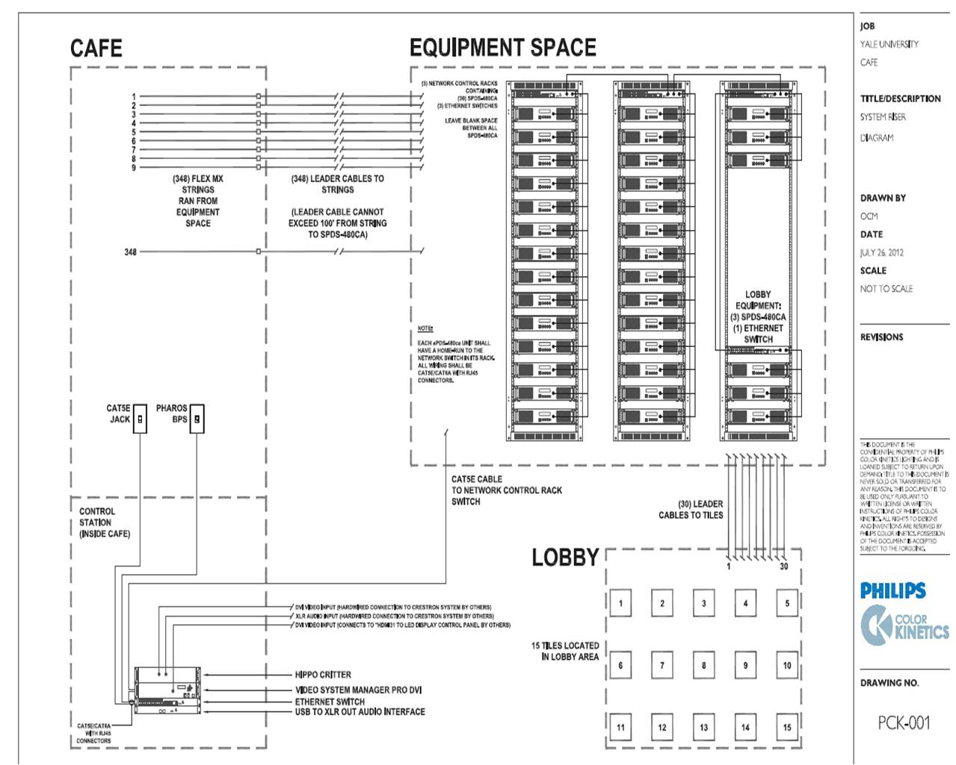
System Riser as submitted by Justin Rawlings (P/CK) email on July 26, 2012

The VSM software can reside on a remote computer with its interface to the VSE provided via the lighting system’s dedicated Ethernet LAN. Once the VSE is configured using the VSM software, this remote computer is not needed for the system to operate.
It is noted that the Yale Engineering VSE has ports for a keyboard/mouse, 4 USB connections and a VGA monitor. These interfaces are not envisioned as being used in this application.
It is noted that the Yale Engineering VSE has digital inputs for both VGA and DVI cables, as well as an analog Composite video input. It is envisioned that only the DVI digital input would be used in this application, with that input signal being delivered as an output from the Hippo Critter media server.
Output from the Hippo Critter is also available as S-video which will not be used in this installation
This assumption requires that access to the Hippo-Critter’s keyboard, mouse, and one com port are provided in the café. Café access to the unit’s additional three com ports, two Ethernet connections, four USB ports and microphone/audio jacks are not envisioned as being needed in the café.
It is noted that while flash drives physically can be used for media file transfer directly to the Hippo Critter, the vendor strongly urges against this. If a flash drive is used, that the drive be independently scanned on a standalone computer using the most reliable virus protection software immediately before being used in the Hippo Critter. Given these warnings and posted precautions, SEAS will not use this option for uploading media files.
This feature only works for Windows PCs. The Screen Thief software must be installed on the non-Hippotizer PC, fix the IP address, and then use whatever is running on the remote PCs screen as the source for direct input to the Hippo Critter.

